TECHNICAL PROJECT REPORT JUNE 2026


DZAIR AI
An Algeria-First AI Ecosystem Platform
Centralizing AI Knowledge, Opportunities & Innovation
“One Platform To Rule Them All” - centralizing AI knowledge, opportunities, and innovation into one unified space.

PREPARED BY
Mohaned Manaa PRODUCT &UI ENGINEERING
Yahia Kerroum BACKEND ARCHITECTURE
Bachounda Essedik Abderrahim DESIGN & DOCUMENTATION
Khalil Ghanem API & INTEGRATIONS
Youcef Chouki RESEARCH, QA AND PROCESSING

SUPERVISED BY
Dr. Sami Belkacem
OVERVIEW

Abstract
Artificial intelligence is advancing rapidly worldwide, yet in Algeria the information needed to learn, build, and innovate with AI remains fragmented across multiple disconnected platforms. This report presents Dzair AI, an Algeria-first AI ecosystem platform that centralizes AI knowledge, opportunities, and innovation into one unified space - gathering experts, organizations, datasets, research papers, projects, jobs, internships, hackathons, and events into a single searchable, verified web platform at https://www.dzair.ai.
The platform combines a Next.js, React, and TypeScript frontend with Supabase for the database and backend services, and Python/FastAPI microservices powering CV parsing, job matching, and automated aggregation of AI news, repositories, and research papers. Developed by a five-member team with the support of the ENSIA V2V Incubator and under the supervision of Dr. Sami Belkacem, the platform was fully built, hosted on its own domain, tested, and made publicly accessible. The report documents the problem, the methodology, the proposed solution, the results obtained, the division of work among the five team members, and the limitations and directions that follow.

KEYWORDS artificial intelligence · ecosystem platform · Algeria · information fragmentation · unified search · CV parsing · job matching · Next.js · Supabase · FastAPI

DOCUMENT INFORMATION
Field | Detail
Project | DzairAI - Algeria-first AI ecosystem platform
Report type | Technical project report
Team | Five members (see title page)
Supervisor | Dr. Sami Belkacem
Repository snapshot | May 10, 2026 · verified May 13, 2026
Date of report | June 2026
NAVIGATION

Contents

Abstract 1
Contents 1
Problem Statement 1
Scope 1
Limitations 1
Methodology 1
2.1 Requirements Analysis 1
2.2 Data Track 1
2.3 Interface Track 1
2.4 Service Track 1
2.5 Tools and Technologies 1
2.6 Project and Risk Management 1
Proposed Solution 1
3.1 Key Features 1
3.2 Direction 1
Results & Discussion 1
4.1 Results 1
4.2 Discussion 1
4.3 Challenges and How They Were Overcome 1
4.4 Limitations 1
Who Did What 1
Conclusion 1
Appendix 1
A Some Market Exhibits 1
B Platform & Brand Artifacts 1
C References 1

SECTION 01

Problem Statement
Artificial intelligence is advancing rapidly worldwide, yet in Algeria the information needed to learn, build, and innovate with AI remains fragmented across multiple disconnected platforms. Students, professionals, startups, and organizations struggle to access reliable and actionable knowledge: educational resources live in one place, job and internship offers in another, datasets and research papers somewhere else, and ecosystem actors (companies, incubators, laboratories, experts) are not mapped in any single, trustworthy directory.
This fragmentation produces concrete consequences for nearly every actor in the ecosystem.
- AI students and researchers waste time searching for verified local resources, datasets, and collaborators.
- Startup founders and ML engineers cannot easily identify partners, mentors, or opportunities.
- Recruiters and job seekers lack a dedicated channel for AI-related positions, internships, and hackathons.
- Event organizers and community members have no shared space to publicize their activities.
- Ecosystem operators lack consolidated, reliable data on which to base decisions.
Beyond fragmentation, decision-makers also struggle to transform global AI trends into practical local solutions adapted to the Algerian context. At the same time, growing youth unemployment increases the urgency of accessible AI education and employment opportunities, since AI skills represent one of the most promising paths toward employability and entrepreneurship for young Algerians.

Scope
The project addresses this problem at the national (Algeria-first) level through a unified web platform that centralizes AI knowledge, opportunities, and innovation. The targeted users include students, researchers, professionals, freelancers, startups, established companies, incubators, universities, and public organizations.

Limitations
The problem treated is limited to information access, discovery, and connection: the platform does not itself deliver AI courses, fund projects, or hire candidates, but rather organizes and surfaces verified pathways to these resources. The quality of the solution also depends on the availability and verification of ecosystem data, on the gradual growth of an active user base, and on the limited budget of a student-led project in its incubation phase.
SECTION 02

Methodology
The team followed a structured, phase-based approach in which a single requirements analysis stage fed parallel work tracks, converging on deployment and ecosystem outreach.

2.1 Requirements Analysis
Requirements were not invented in isolation; they were gathered from the people the platform is meant to serve. The main inputs were: information collected through online forms and discussions; meetings with Algérie Télécom and Eyconet, which gave an industry perspective on ecosystem needs; questions and suggestions raised by students during earlier presentations of the project; and, most importantly, regular meetings with Dr. Sami Belkacem, the teacher and supervisor of this project, whose feedback shaped the platform’s direction at every stage.

2.2 Data Track
The database was first structured around users, profiles, and resources. Data collection then benefited from two main sources: the forms previously shared by Dr. Sami Belkacem on LinkedIn, which provided early insight into the Algerian AI community, and scraping pipelines targeting well-known Algerian repositories and research papers, which seeded the platform with real, relevant content.

2.3 Interface Track
The UI/UX went through a large number of iterations. Early layouts were repeatedly reworked based on supervisor feedback and student reactions before converging on the final visual identity and experience structure, which was then implemented as responsive frontend pages.

2.4 Service Track
The core intelligent services of the platform are CV parsing and job matching, which connect user profiles to relevant opportunities. These AI features were developed in Python and exposed through FastAPI services, alongside the scrapers that aggregate AI news, public repositories, and research papers. This track also covered the backend APIs, the authentication system (login, registration, and secure account management), and security testing (access control, data protection, and vulnerability checks).

2.5 Tools and Technologies
The platform combines a Next.js, React, and TypeScript frontend with Supabase for the database and backend services, and Python microservices built with FastAPI for the AI features (CV parsing, job matching, and the news, repository, and paper scraping pipelines). The team also acquired the domain name dzair.ai, giving the project a short, memorable national identity. Project documentation was maintained in a synchronized Notion workspace (product requirements document, SWOT analysis, business model canvas, market analysis, risk assessment, system design, and roadmap).

2.6 Project and Risk Management
Coordination relied on clear task distribution, weekly meetings, and progress tracking. Five risk categories - technical, human, financial, security, and organizational - were identified and paired with mitigation measures such as regular testing, code reviews, backups and monitoring; secure authentication and vulnerability testing; controlled budgeting supported by incubator resources and free tools; and defined responsibilities within the team.
SECTION 03

Proposed Solution
The proposed solution is Dzair AI, a unified, Algeria-first AI ecosystem platform, built, hosted, and tested as a publicly accessible web application at https://www.dzair.ai, under the project’s own dzair.ai domain. Instead of forcing users to navigate scattered sources, Dzair AI gathers the national AI landscape - people, organizations, resources, and opportunities - into one searchable, verified space.

3.1 Key Features
- Discovery and search. A global search engine spanning the platform, plus dedicated discovery of experts, datasets, research papers, research laboratories, projects, and research opportunities.
- Opportunities. Job listings, internship offers, hackathons, and event listings connecting talent with organizations.
- AI-powered matching. CV parsing and job matching services that analyze user profiles and automatically connect them to the most relevant opportunities.
- Automated content aggregation. Scraping pipelines that keep the platform supplied with the latest AI news, public repositories, and research papers, with a focus on Algerian content.
- Trust and quality. Admin verification and surveillance of content, secured data, and ORCID integration for researcher identity.
- Usability. An intuitive UI/UX refined over many iterations, bookmarking of any item, notifications on updates, and responsiveness on low-end devices to maximize accessibility.

3.2 Direction
Rather than chasing fixed numerical targets, the solution is oriented around a clear direction: keep enriching the verified ecosystem data, keep improving the matching and aggregation services, and grow an active community of students, researchers, professionals, and organizations around the platform.
SOURCE CODE github.com/mohaneddz/DzairAI
SECTION 04

Results & Discussion

4.1 Results
- Functional platform. Dzair AI was fully developed, hosted on its own domain, tested, and made publicly accessible as a working AI ecosystem platform - not a prototype.
- Working AI services. The CV parsing, job matching, and scraping pipelines (news, repositories, research papers) run as Python/FastAPI services integrated with the platform.
- Early community. An active community has started forming through platform registrations and ecosystem engagement.
- Incubation. The project was accepted into the ENSIA V2V Incubator program, gaining mentorship and operational support.
- Ecosystem contact. Communication was established with organizations including Algérie Télécom and Eyconet, while actors such as Capture Doc, Emploitic, and the CRTI research center helped shape the project vision.
- Data acquisition. Structured data on Algerian companies, startups, incubators, and AI entities was acquired and organized to power the platform’s discovery features.

4.2 Discussion
These results validate the project’s core hypothesis: there is a real local need for a single trusted entry point into the Algerian AI ecosystem, and such a platform can be delivered with student-level resources when supported by an incubator and an engaged supervisor. Grounding the requirements in real conversations - with industry, with students, and with Dr. Sami Belkacem - kept the platform focused on features people actually need, such as job matching, rather than on speculative ones.

4.3 Challenges and How They Were Overcome
The team faced challenges in development, data collection, security, internal coordination, and partnership communication. Technical instability was addressed through regular testing, code reviews, backups, and monitoring. The difficulty of gathering reliable local data was reduced by building scrapers for Algerian repositories and papers and by leveraging the community reached through the LinkedIn forms. Security concerns were mitigated with secure authentication, access control, and vulnerability testing. Coordination and workload pressure were managed through task distribution, weekly meetings, and progress tracking, while financial constraints were limited by incubator support, free tools, and controlled budgeting.

4.4 Limitations
The platform remains at an early stage: the user base is still small, ecosystem data requires continuous verification and enrichment, the matching services will improve as more CVs and offers flow through them, and admin-based verification will need to scale with growth. None of these limitations undermines the result: the project is a solid step forward, and the experience gained gives the team a much clearer idea of what to build next.
SECTION 05

Who Did What
DzairAI was delivered by a five-person team under the supervision of Dr. Sami Belkacem. Responsibilities were divided by domain, but there is still more on it.
Mohaned Manaa FRONTEND & UI ENGINEERING
- Owned overall product direction and the single source-of-truth project document.
- Consistent work on the full platform, different pages, bug fixing and improvements.
- Presenting the team in all meetings, presentations and documentations.
- Multiple important and optional features.
- Documentations and statistics, Notion platform surveillance.
- Current Design and Identity.
Yahia Kerroum PRODUCT & BACKEND ARCHITECTURE
- Built the Python backend features and hosted the servers.
- Integration of Business Logic and explored different visions in different branches.
- Implemented scrapers for news, repositories, projects and experts.
- Pivotal role in all presentations, and solid marketing with important figures in big events.
- Fixing issues and overall polish.
Bachounda Essedik Abderrahim DESIGN AND DOCUMENTATION
- Assistance in preparing presentations and semiweekly progress reports (sessions)
- Assistance in the Notion documentation of the progress and the design process.
- Proposed potential new design implementations.
- Worked on the final submission documents.
Khalil Ghanem API & INTEGRATIONS
- Implemented multiple features and pages such as saved searches, applications systems...
- SMTP server configuration for email features.
- OAuth, advanced login features, onboarding.
- Tasks management, consistent code quality control.
- Experts’ data’s reversal and filling the blanks.
- Bug Fixes and Polish
Youcef Chouki RESEARCH, QA & PROCESSING
- Led market, SWOT, and competitor research with dated, cited evidence.
- Companies and Datasets acquisition, preprocessing and augmentation.
- Final dataset features, manual data hunting and UX enhancements everywhere.
- Pivotal role in all decisions and business meetings.
- Bug fixes and platform testing, polishing the entire experience.
SECTION 06

Conclusion
Dzair AI set out to solve a clearly identified local problem - the fragmentation of AI knowledge, opportunities, and ecosystem data in Algeria - and delivered a real, hosted, and tested platform on its own domain, complete with working AI services for CV parsing, job matching, and automated content aggregation. The project confirmed that such a platform is feasible with the team’s skills, the chosen technologies (Next.js, React, TypeScript, Supabase, and Python/FastAPI), and the support of the ENSIA V2V Incubator and of the project supervisor, Dr. Sami Belkacem.
Challenges and limitations were real - in development, data collection, security, and coordination - but each one taught the team something concrete about building and operating a product. Taken as a whole, the project is a good step forward: the team now has a working foundation, validated needs, and a much clearer idea of the road ahead - growing the community, deepening the data and matching services, and continuing to build the platform that this community deserves.

Recommendations for Future Work
- Validate paid demand quickly through small pilot cohorts, rather than optimizing for audience growth alone.
- Grow owned distribution channels - newsletter, community, direct traffic - to reduce dependency on social-platform algorithms.
- Harden data governance with provenance requirements and quality controls for contributed datasets.
- Explore a community-owned, mission-first institutional model, and a measured expansion to the wider MENA region and the Algerian diaspora.

SECTION 07

Appendix
Selected exhibits from the DzairAI platform and its supporting analysis, the pitching presentation.

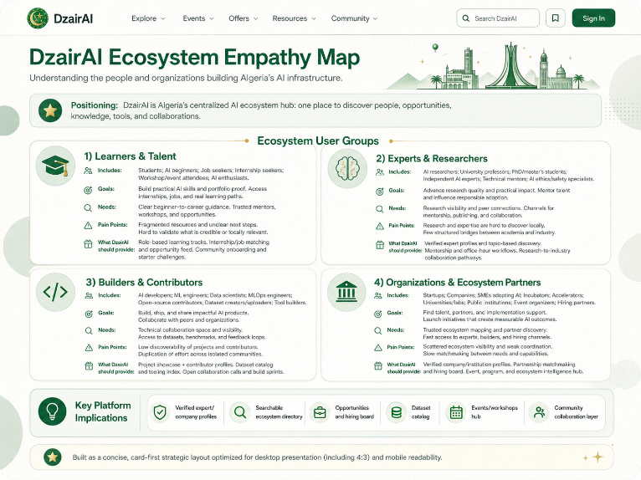
A Some Market Exhibits
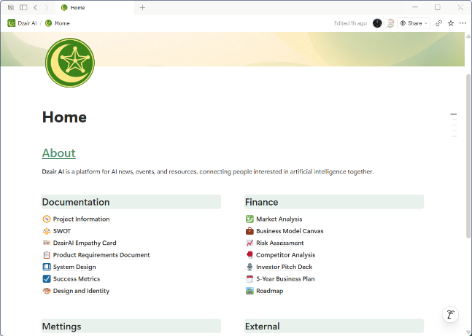
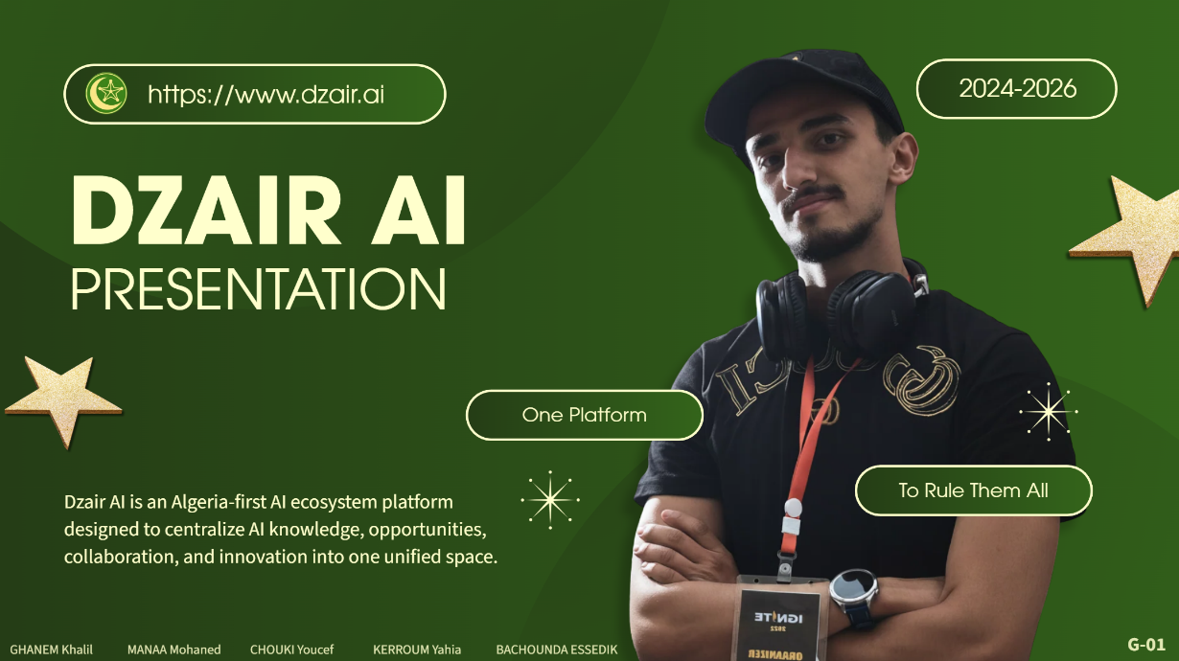
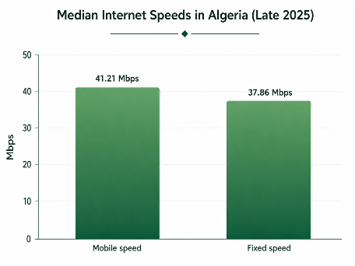
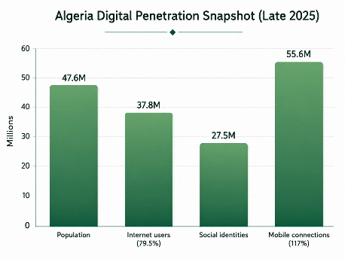
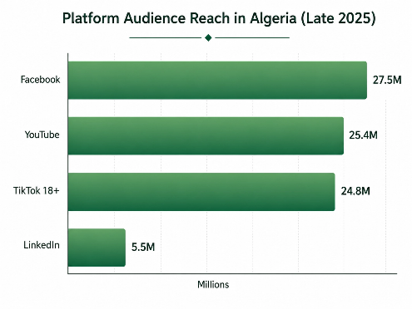

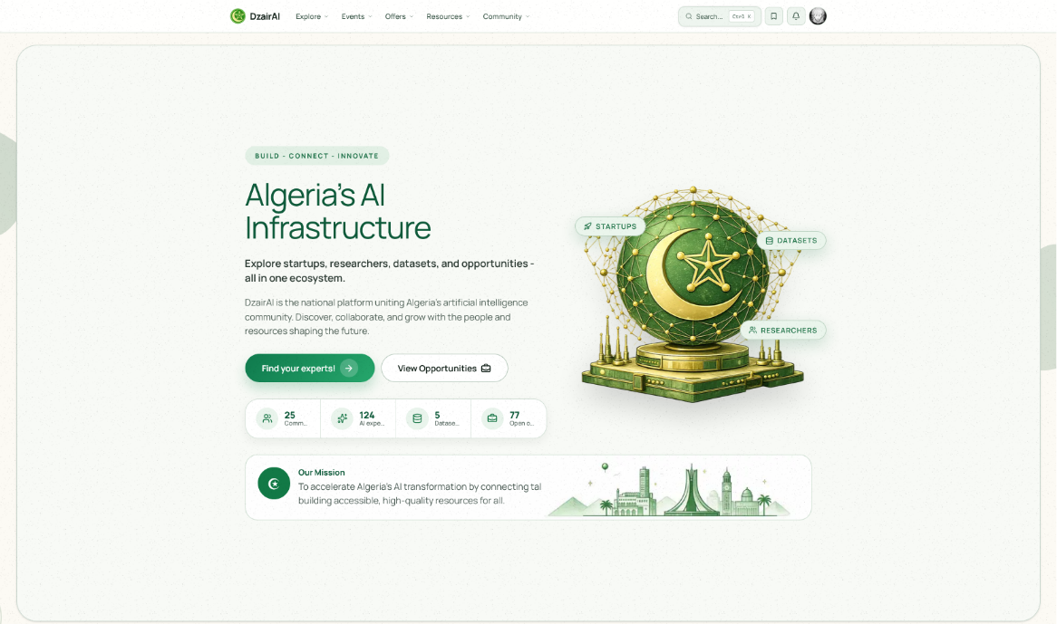
B Platform & Brand Artifacts
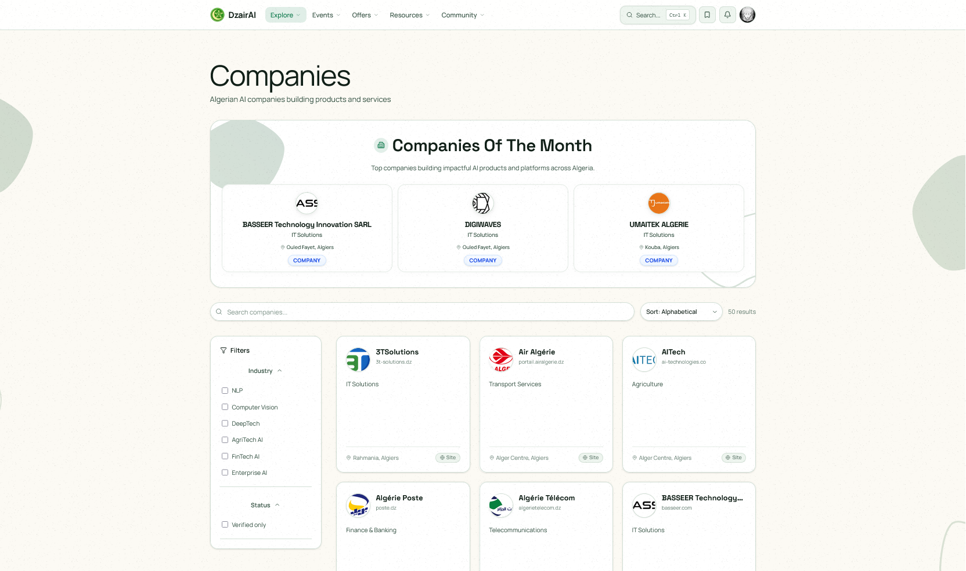
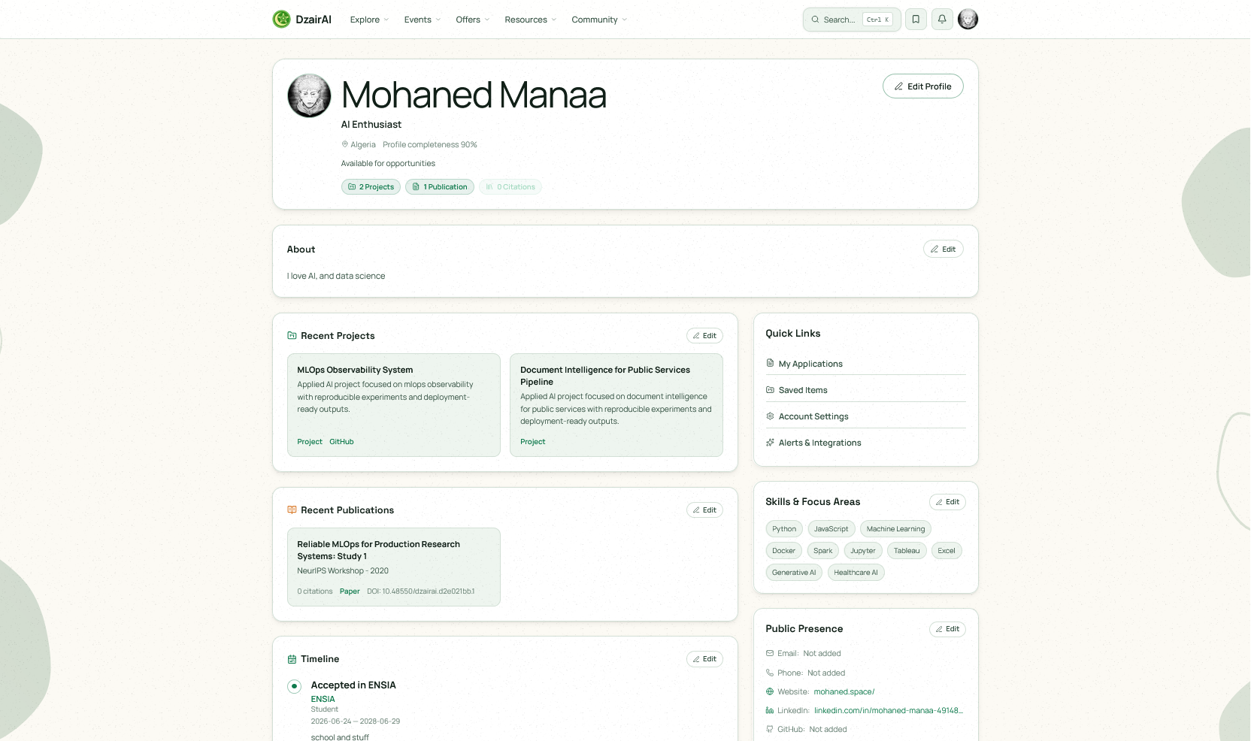

C References
External sources cited in this report; data is limited to the periods indicated.
[1] DataReportal - Digital 2026: Algeria (late-2025 data). https://datareportal.com/reports/digital-2026-algeria
[2] World Bank - Algeria Selected Indicators (2025 estimate sheet). https://thedocs.worldbank.org/en/doc/7210a1bcbdc24a6d73c62228ee1e3e70-0500042021/related/data-dza.pdf
[3] World Bank Human Capital Brief - Algeria (October 2024). https://humancapital.worldbank.org/content/dam/sites/data/humancapital/pdf/country-briefs-2024/Algeria.pdf
[4] McKinsey - The State of AI in 2025 (November 5, 2025). https://www.mckinsey.com/capabilities/quantumblack/our-insights/the-state-of-ai
[5] Stanford HAI - AI Index 2026, Economy chapter. https://hai.stanford.edu/ai-index/2026-ai-index-report/economy
[6] Gartner - GenAI spending forecast, 2025. https://www.gartner.com/en/newsroom/press-releases/2025-03-31-gartner-forecasts-worldwide-genai-spending-to-reach-644-billion-in-2025
[7] World Economic Forum - Future of Jobs Report 2025. https://www.weforum.org/press/2025/01/future-of-jobs-report-2025-78-million-new-job-opportunities-by-2030-but-urgent-upskilling-needed-to-prepare-workforces/

Internal artifacts. Repository and product references (Next.js / React / TypeScript / Supabase) reflect the project snapshot of June 9, 2026

